- 总则General Policy
为保障公司信息系统的安全，规范系统访问的授权与管理，防止未经授权的访问，特制定本总则。涉及敏感数据和密钥的计算机设施必须放在高安全区，受门禁系统、监控系统、报警系统管控
To ensure the security of the company's information system, standardize the authorization and management of system access, and prevent unauthorized access, this general principle is formulated. Computer facilities involving sensitive data and keys must be placed in high-security area and controlled by access control systems, monitoring systems, and alarm systems
- 适用范围Scope
本总则适用于公司内部员工、外部合作方及其他相关人员对公司信息系统的访问行为，包括但不限于操作系统、应用系统、网络设备及存储设备的访问。
These general provisions apply to the access to the internal employees, external partners, and other related personnel concerning the company's information systems, including but not limited to access to operating systems, application systems, network devices, and storage devices.
- 控制流程Control Processes
  - 账户分类Application description
系统分类System classification | 系统用途System purpose | 账户类型Account Type
Firewall | 用于网络隔离Used for network isolation | 域控账户Domain Control Account
VMware ESXI/VCSA | 用于服务器虚拟化Used for server virtualization | 应用系统账户Application system account
Windows | 用于服务器或作业终端Used for servers or job terminals | 域控账户Domain Control Account
 | 用于IT架构和生产网管理机  Used for IT architecture and production network management | 域控账户Domain Control Account
Linux | 用于服务器Used for servers | 域控账户Domain Control Account
Database | 用于应用系统的数据存储  Data storage for application systems | 应用系统账户Application system account
SFTP/FTP | 用于数据传输或文件交换  Used for data transmission or file exchange | Linux本地账户Linux Local Account
Hexhome | 用于密钥管理Used for key management | 应用系统账户Application system account
DMS | 用于生产数据管理  Used for production data management | 域控账户Domain Control Account
UICC Data Generation System | 用于UICC数据生成Used for UICC data generation | 域控账户Domain Control Account
EUICC PKI Manage System | 用于EUICC PKI管理和数据生成  Used for EUICC PKI management and data generation | 域控账户Domain Control Account
Door Access System(DAS) | 用于安全区域门禁管理  Used for access control management in secure areas | 应用系统账户 Application system account
Eventlog Analyzer | 用于系统日志收集和分析  Used for system log collection and analysis | 应用系统账户Application system account
SVN | 用于研发源代码版本管理  Used for R&D source code version management | 应用系统账户Application system account
Patch Manager | 用于Windows和Linux补丁更新  Used for Windows and Linux patch updates | 域控账户Domain Control Account
RSP Dpplus | 用于SM Consumer 业务流程处理  Used for SM Consumer business process handling | 域控账户Domain Control Account
RSP DP | 用于 M2M 业务流程处理（profile生成）  Used for M2M business process handling (profile generation) | 域控账户Domain Control Account
RSP SR | 用于 M2M 业务流程处理（profile派发）  Used for M2M business process handling (profile distribution) | 域控账户Domain Control Account
RSP EIM | 用于 IOT 业务流程处理  Used for IoT business process handling | 域控账户Domain Control Account
SM-KMS | 用于SM密钥管理Used for SM key management | 域控账户Domain Control Account

  - 账户管理Account Management
根据使用的计算机系统和岗位职责制定《岗位权限设置规则》，所有对这些系统的账户和权限管理都须依照这个规则来执行。
According to the computer system used and job responsibilities, establish the 'Job Permission Setting Rules', and all account and permission management for these systems must be carried out in accordance with this rule.
账户管理依照以下流程：
Account management follows the following process:
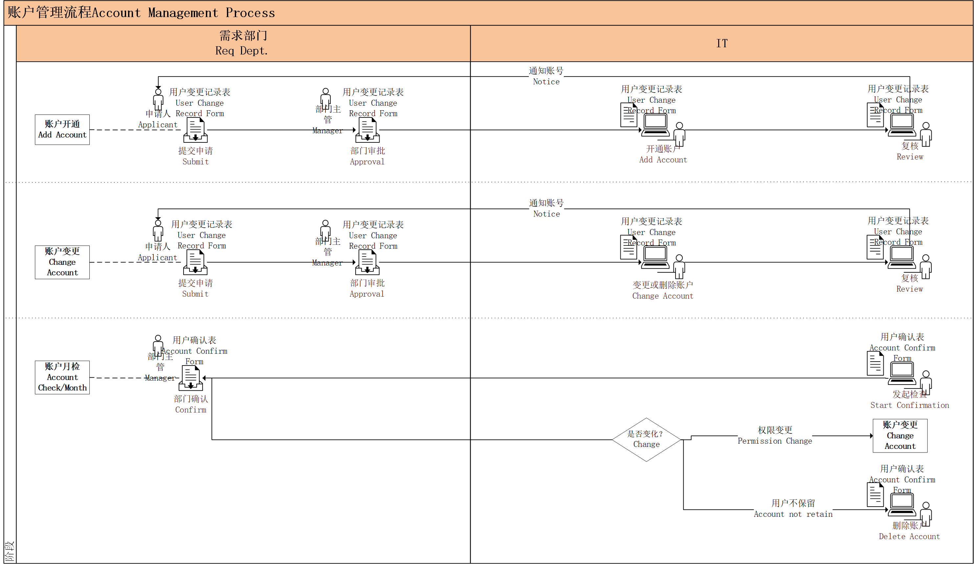
1).账户开通：由需求部门提出申请，部门领导审批，然后交由IT管理员开通账户，再由另一个IT人员确认无误后将账号通知到申请人。全过程记录在《用户变更记录表》。完成后并更新《用户权限一览表》，对于业务部门代客户申请的SFTP账号，还需在《用户权限一览表》中记录其所属业务部门、对接人、账号有效期、客户白名单IP。
Account creation: The application shall be submitted by the demand department, and then the IT administrator shall be entrusted to open the account. After that, another IT staff shall confirm that there is no error and notify the applicant of the account. The whole process shall be recorded in the 'User Change Record Form'.After completion, update the User Permission List. For SFTP accounts applied by business departments on behalf of clients, the following information shall also be recorded in the User Permission List: the affiliated business department, contact person, account validity period, and client whitelist IP addresses.
2).账户变更：当因员工调岗导致账户需要变更时，由需求部门员工提出申请，经由其部门主管审批，然后交由IT管理员对其账户进行变更，再由另一个IT人员确认无误后将新账号通知到申请人。全过程记录在《用户变更记录表》。
Account change: When an employee needs to change their account due to a job transfer, the requesting department employee shall submit an application, which shall be approved by their department supervisor and then submitted to the IT administrator for account change. After confirmation by another IT personnel, the new account shall be notified to the applicant. The entire process is recorded in the 'User Change Record Form'.
3).账户检查：IT人员每月对计算机系统中的账户进行检查。将所有计算机系统中的账户按部门分到《用户确认表》发给各部门主管确认，由部门主管填写用户状态后回执给IT，IT管理员再根据确认结果对账户进行处置。对于业务部门代客户申请的SFTP账号，由业务部门确认用户状态后回执给IT，IT管理员再根据确认结果对账户进行处置，涉及SFTP客户白名单变更的情况，参考《网络安全控制流程》第三章进行处置。账户检查完成后，IT管理员更新《用户权限一览表》。
Account check: IT administrators conduct monthly checks on accounts in the computer system. Distribute all accounts in the computer system by department to the 'User Confirmation Form' and send it to department heads for confirmation. The department heads will fill in the user status and send it back to IT, and the IT administrator will then dispose of the accounts based on the confirmation results.For SFTP accounts applied by business departments on behalf of clients, the business department shall confirm the user status and provide a receipt to IT. The IT administrator will then handle the account based on the confirmation results.In case of changes to the SFTP client whitelist, refer to Chapter 3 of the ‘Network security control process’ for handling.After completing the account inspection, the IT administrator shall update the ‘User Permission List’.
账户状态Account Status | 处置方法Disposal Method
保留reserve | 不处置not disposing
不保留not retain | 在系统中删除该账户delete account from system
权限有误Permission change | 走账户开通流程，在系统中对账户权限进行变更Follow the account activation process and make changes to account permissions in the system
4).账户锁定解锁：账户锁定由密码策略生效。当出现账户锁定需要解锁时，由账户持有人通知IT管理员进行解锁。
Account lockout and unlock: Account lockout is effective through password policies. When an account is locked and needs to be unlocked, the account holder shall notify the IT administrator to unlock it.
5).特权账号（系统默认管理员账号）：特权账号默认禁用。密码由CISO保管。
Privileged account (default administrator account in the system): privileged accounts are disabled by default. The password is kept by CISO.

  - 密码策略Passwords Policy
    - 下列为公司密码策略:
The following is the company's password policy, which applies to all systems:
- 强制密码历史24次。
Enforce password history is set to 24.
- 密码最长期限30天。
Maximum password age is set to 30.
- 密码最短期限1天。
Minimum password age is set to 1
- 密码最小长度14个字符。
Minimum password length is set to 14.
- 密码必须符合复杂度要求。（含有大小写字母，特殊符号和数字等任意3种的组合）
Password must meet complexity requirements. any combination of three types (e.g., uppercase/lowercase letters, symbols, and numbers)
- 使用可逆加密存储密码设为禁用。
Storing passwords using reversible encryption is disabled.
- 帐户锁定阈值设置为5次。
Account lockout threshold is set to 5.
- 账户锁定时间设置为永久，直到IT管理员手动解锁。
Account lockout duration is set to 0, until the IT administrator manually unlocks the account.
- 重置帐户锁定计数器设置为30分钟。
Reset account lockout counter after is set to 30.
- 对于无法实现以上要求的第三方软件或系统，使用其提供的最强密码策略。
For third-party software or systems that do not meet the above requirements, use their strongest password policy.

    - 补充说明 Additional Notes
密码的保存必须是受到保护的加密方式、没有共享或其他可能性提供给其他人知道，包含系统管理员。正在登入系统时，密码是不可以显示出来的。密码不允许被公开或记录在纸上。密码也不得记录于未加密的储存媒体或任何自动登入的程序。如果有需要的话，密码只能保存于密封的信封袋。
Passwords stored must be protected with strong encryption methods and never shared, available or known to others, including administrators. No password is to be displayed in clear when it is being entered. Password shall not be shared or kept on paper. Password shall not be stored in any medium in clear, macro, function key or any auto logon script. Password may only be kept in tamper-evident sealed envelope if necessary.
如果怀疑密码可能失窃或受到损害时，帐号需立即锁定，直到帐号和密码改变。
If any password is compromised or suspected to be compromised, the account is immediately locked until the UserID and password are changed.
系统存取权必须只能允许在基本的授权上。未经授权的存取资料夹或档案是被禁止的。
Access rights shall only be granted on authorized need basis. User access into unauthorized folders or files is strictly prohibited.
当个别的职员离开公司或暂时停职离开其职位时，帐户必须被锁。
User accounts are locked when the respective employee leaves the company and deleted upon completion of leaving clearance.
- 相关文件Related Documents
- 相关记录Related Forms
《岗位权限设置规则》Rules for Setting Job Permissions
《用户变更记录表》User Change Record Form
《用户确认表》User Confirmation Form
《用户权限一览表》User Permission List

Document History 文件历史记录

版本  Version | 日期  Date | 变更简述  Brief Description of change | 编辑  Editor | 审批  Auditor | 批准  Approve
1.0 | 2025/1/15 | 新版发布  New version release | 郑炳佳 | 杨龙威 | 郭思才
2.0 | 2025/4/30 | 修改信息等级  Modify information Class | 郑炳佳 | 杨龙威 | 郭思才
3.0 | 2025/5/15 | 修正部分英文描述  Revise some English descriptions | 郑炳佳 | 杨龙威 | 郭思才
4.0 | 2025/7/10 | 账号分类增加SM系统  Add SM system to Application description | 郑炳佳 | 杨龙威 | 郭思才
5.0 | 2026/5/10 | 第三方软件或系统密码策略要求  Third-party software or system password policy requirements | 郑炳佳 | 杨龙威 | 郭思才

编辑：  Editor: | 审批：  Auditor: | 批准：  Approve:

